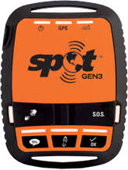
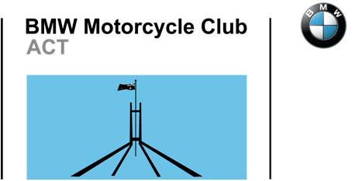
BMWMCCACT
SPOT Profile / Loan
Request Form

The BMW Motorcycle Club ACT (BMWMCCACT) owns a SPOT Gen3 GPS tracker that can be borrowed by financial members free of charge. There is a A$50 refundable deposit to encourage its timely return.
This form allows a Club member (user) to (1) request a new individual profile, (2) borrow the SPOT Gen 3, or (3) change any or all of the 3 customised messages for their profile and next adventure.
The borrowing member (user) is responsible for supplying the 4 x AAA lithium batteries and providing up to 4 contact and emergency name(s), email address(es) and/or contact telephone number(s) of person(s) they want to notify or respond to the SPOT pre-formatted and automated text messages. The BMWMCCACT, Committee or Members do not monitor or respond to any message including SOS emergency messages. The Club website SPOT Track link page is for the information of members and interested persons only and only shows GPS cocordinates.
Your Profile
Your Name:
Contact Telephone:
Contact Email:

I want to and borrow SPOT from to .
Customised Messages
Whilst you can customise any of the following 3 messages they cannot be readily changed once you are on the road. SPOT is one way communications; a message recipient cannot respond to you by return phone or email via SPOT.
Check In. Let contacts know where you are and that you're okay with a pre-programmed message.
Custom. Let contacts know where you are by sending a pre-programmed message with your GPS location.
Help/SPOT S.O.V. Request help from your friends & family at your GPS location.
S.O.S Only to be used for life threatening emergencies.  This message is pre-formatted and cannot be changed by the User. Activating sends your GPS location to SPOT HQ GEOS (Canada) who then contact Australia's emergency coordinating response agency AMSA. The local response time depends on where you are. |  | 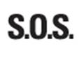

Who do you want to receive your messages?
Once you have selected and pressed the (1) Check In, (2) Custom or (3) Help/SPOT SOV button your preformatted message will be sent to your contacts as a text message or as an email + Google Map link.
Only use the S.O.S button for life threatening emergency and will send a message to the emergency services and nominated contacts. You can select 1 - 4 contacts for each or all four messages.
Contact 1 |  |  | Messages
Name
Email
Telephone.  mobile or landline leave out leading 0’s |  | 001161
Contact 2 |  |  | Messages
Name
Email
Telephone.  mobile or landline leave out leading 0’s |  | 001161
Contact 3 |  |  | Messages
Name
Email
Telephone.  mobile or landline leave out leading 0’s |  | 001161
Contact 4 |  |  | Messages
Name
Email
Telephone.  mobile or landline leave out leading 0’s |  | 001161
Conditions of Use:
1. The BMWMCCACT SPOT is only available for loan to financial members of the BMWMCCACT.
2. A $50 deposit is required at time of pick up and the user/borrower is responsible for providing the 4 x AAA lithium batteries if, when and as required.
3. Don't know how to use SPOT? Then check out the Club SPOT website before you go and/or print off the 'how to' instructions.
4. The BMWMCCACT, Committee or Members are NOT responsible for monitoring or responding to any message. It is your responsibility to arrange for someone to monitor and respond to any message.
5. The S.O.S button is for life threatening emergency use only. This does not include your having a bad day, mechanical breakdown or any other trip related issue.
Submit the Form
Once you have completed this form email it to SPOT@bmwmccact.org.au and the Club will get in contact with you.
Allow a minimum 2 weeks for your profile to be set up and before leaving on your adventure.

